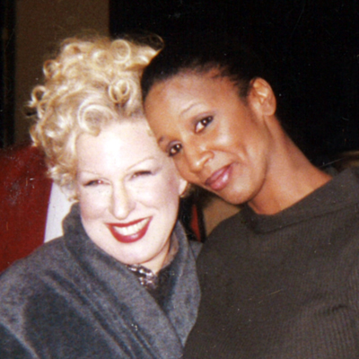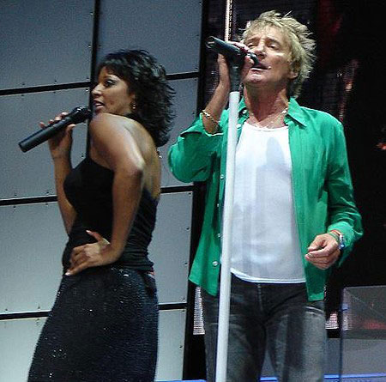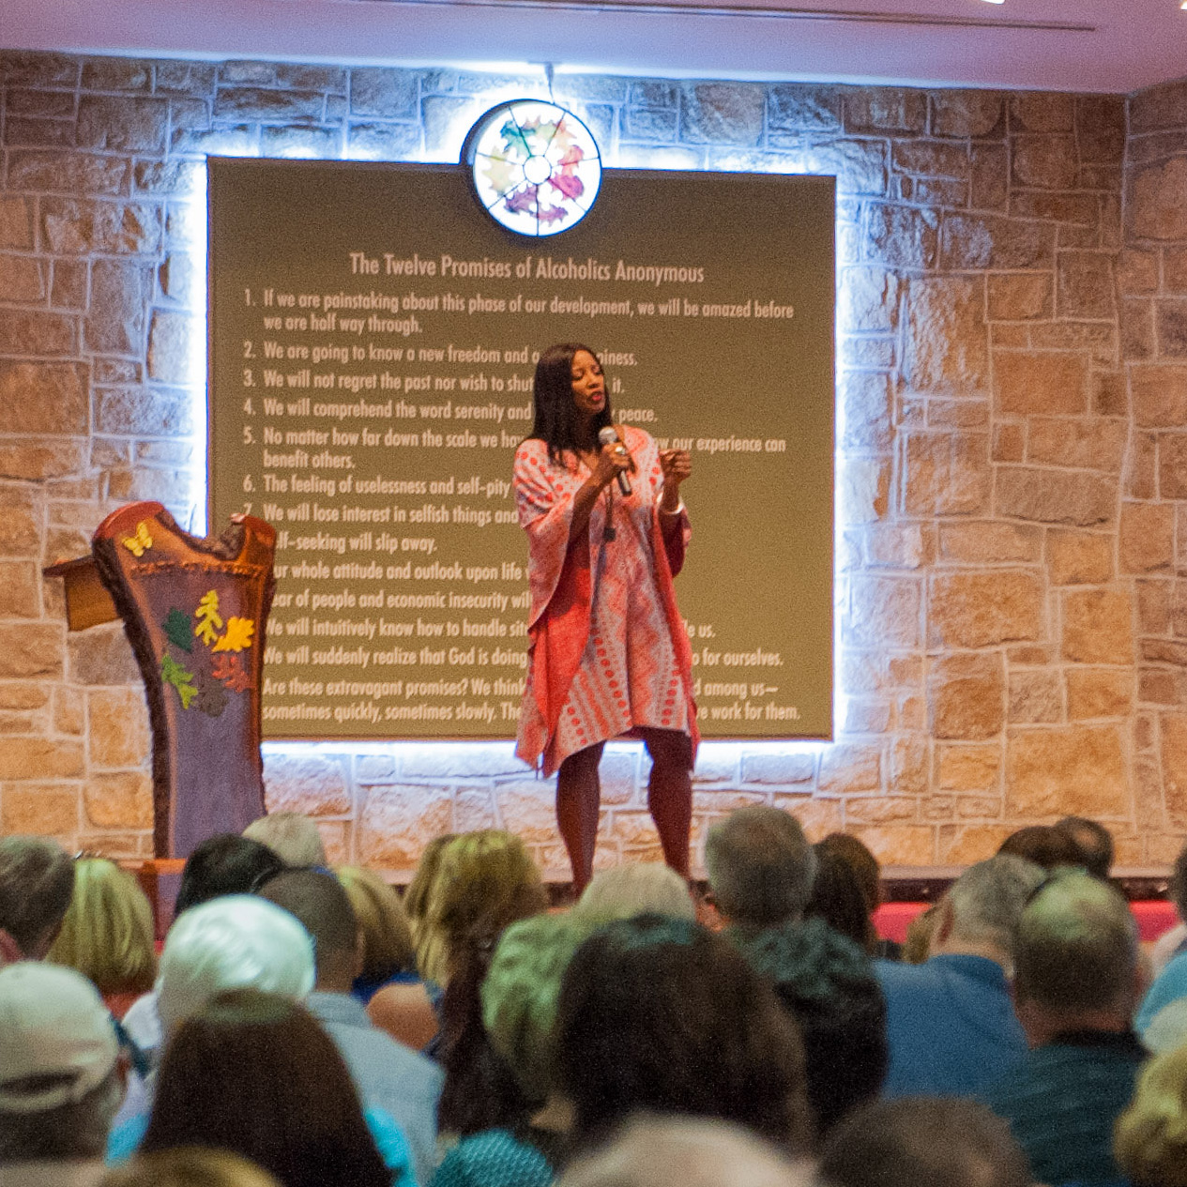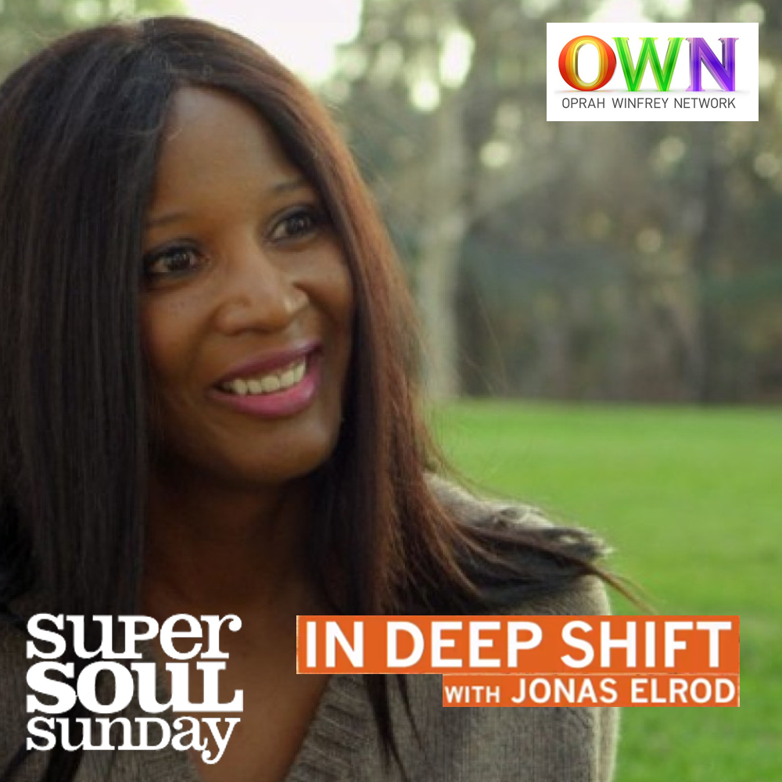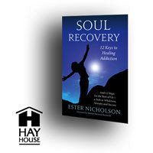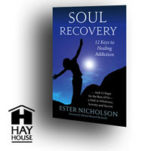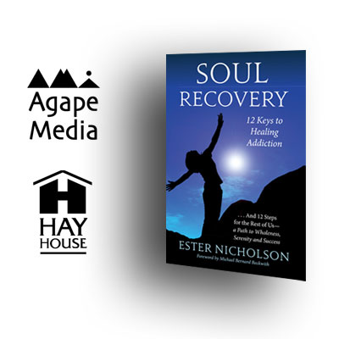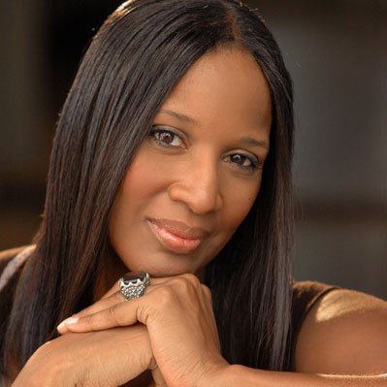

## Appearing at: VENUE NAME

## Speaking on August 4th at 10AM

## plus a special workshop at 3PM

## Ester’s *Soul Recovery* unifies the spiritual core of the 12-step Anonymous recovery program and broadly-accepted spiritual practices in a deeply compassionate program. Her presentation of this healing model is an opportunity not to be missed…

## Ms. Nicholson, speaker, teacher, renowned singer and author of *Soul Recovery – 12 Keys to Healing Dependence* is a recovery specialist employing spiritual practices to uncover and heal the root causes responsible for patterns of dependence. Her comprehensive teaching has been heralded: “The 12 Steps for the Rest of Us,” as it guides attendees in core concepts and integrated practices that apply to everyone – even those who have no history of substance abuse or experience with the 12 Steps.

## Ms. Nicholson will also be available for private counseling clients on DATE. Be sure to sign up early for both workshop and private sessions.

## See *CONTACT NAME* for additional details.

# Ester Nicholson

For more information, please visit: www.soulrecovery.org